|  |  |
| --- | --- |
| **20**  **December** | **2022** |
|  |  |

ROI DRIVEN DIGITAL MARKATING

Prepared From

thailandvisabd.com

Submitted by

|  |
| --- |
| Zoom Digital is all about ROI. Our result driven approach make sure that every dollar you spend with us bring you back the result you expecting. More Sales, More Leads and More Happy Customers. |
|  |

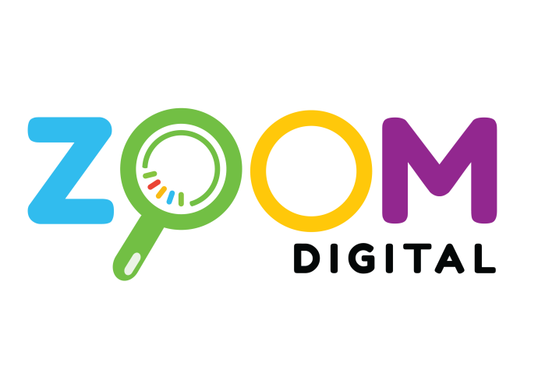

SEO Proposal for thailandvisabd.com

# Welcome to ZOOM DIGITAL

***Search engine optimization,*** *is the process of* ***Google improving your website*** *in a way that lets users find your business more easily in search results.* ***ZOOM Digital*** *Best SEO Service Provider and a* ***large team of 150+ SEO & Digital marketing specialists****.*



## What Makes Us Different

*This gives us a clear role and responsibility within the business community. We help companies to grow with confidence. We do create fulfilling career opportunities service.*



## Our Resources

*Welcome to the* ***Google SEO Guide,*** *your complete, all-in-one guide to ranking competitively in Google’s search engine. SEO Tools Keyword Research,* ***SEO Audit & Crawl,*** *Backlink Research,* ***Rank Tracking, SEO Toolbar****.*

## Why Choose Us?

*Spot On-Site Issues That Could Harm Your* ***SEO Performance****. Precise crawling. Comprehensive* ***SEO audit.*** *Money-back guarantee. Caring customer support. Services: In-depth website audit, Key SEO issues detection, Advanced link analysis.*

# The Value of SEO

You have probably heard the term “SEO.” You probably know that it is something your company needs. But, do you know all of the value you will see by optimizing your site for search engines?

When you invest in SEO, you will see a multitude of benefits.

**Higher search rankings**: Your web pages will appear more frequently and in higher positions on SERPs (search engine results pages)

**Increased organic traffic**: More visitors will land on your web pages through search engines (so you don’t have to pay for traffic)

**Increased brand awareness and authority**: Your brand will appear more frequently which increases your visibility and leads to your website being used as a resource by other websites and publishers

**Increase in number of leads and sales**: As your website appears in front of a larger audience, it becomes a silent salesperson that can collect leads and drive sales from online searchers

**Lasting results**: When you improve a site’s SEO, the work often creates long-term improvements and compounding returns that can get better over time

SEO is a vital tool in building and growing your company's online presence, but it is not a one-time project that will give your brand a lasting boost.

SEO is a long-term practice that works best over time. SEO strategies that are implemented today should be given at least six months to show results. Once that value kicks in, strategies continue to work.

# SEO Ranking Factors

Google uses over 200 factors to rank web pages for SERPs. As part of our partnership, we will assess and prioritize many of these factors to improve your site. Some of those factors include:

**On Page SEO**

|  |  |
| --- | --- |
| * + *Meta Descriptions*   + *Meta Titles*   + *Content Quality*   + *Content Length*   + *Content Freshness*   + *URL Structures*   + *Internal Links*   + *Outbound Links* | * + *Image Title Tags*   + *Keyword Usage*   + *Site Depth*   + *Rate of Audience Engagement*   + *Redirects*   + *Duplicate Content*   + *Social Tags*   + *Broken Links* |

**Off Page SEO**

* + *Number of Inbound Links*

**Technical SEO**

* + *Site Speed*
  + *Mobile Friendliness*
  + *Crawlability*
  + *Meta Security*
  + *Secure Forms and Data Entry*

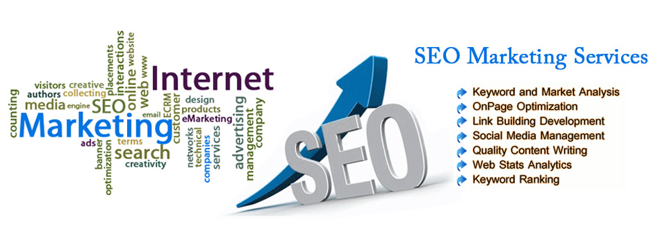

# Plan of Action

To improve your website’s SEO, our strategy resolves these issues through the followings strategies.

|  |  |
| --- | --- |
| **Strategy** | **Description** |
| **Full Site Audit** | We perform a complete audit of your website’s onsite SEO, offsite SEO, and technical SEO. |
| **Keyword Research** | We research up to Zoom digital keywords to find the best opportunities for connecting with your target audience and appearing in search. |
| **Competitor Research** | We assess your client’s competitors to see how they are performing and what you need to do to top them. |
| **Technical Optimization** | We implement technical upgrades that help your site meet the requirements and best practices set by Google. |
| **Content Strategy** | We expand site depth and build additional on-site content through a blog and targeted landing pages. |
| **Link Building** | We gain links back to your website. |

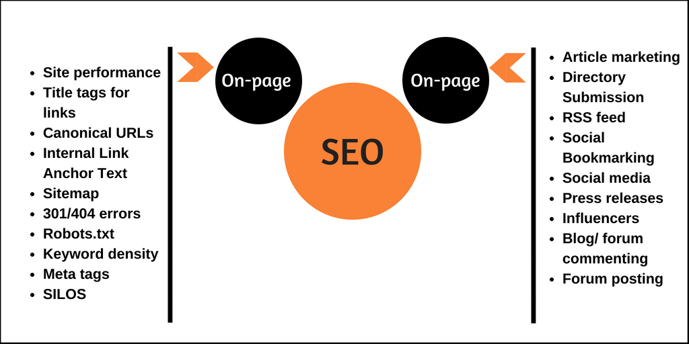

|  |
| --- |
| **Content Marketing** |
| 1. Sponsored Content |
| 1. Landing Page |
| 1. Blog |
| 1. Website |
| 1. Mobile App |
| 1. Mobile Alerts |
| 1. Email Newsletter |

# Our Strategy & Reporting

Because SEO is an ongoing task, our plan will include an initial set-up phase and ongoing monthly plans.

## Phase One: Initial Setup

The table below outlines Phase One. As each task is complete, you will receive a report of the work.

|  |  |  |
| --- | --- | --- |
| **Task** | **Deliverable** | **Audience** |
| **Keyword Research** | Site Relevant with 50 keyword setup | Dhaka Base |
| **Keyword Ranking** | List of Top 20 keywords &metrics Ranking | BD |
| **Competitor Research** | Report of competitor keywords and site backlink | World wide |
| **Technical Optimization** | Report on technical upgrades | SEO Site Checkup |
| Local SEO | Local Business setup for business | Dhaka AREA |
| **Video with YouTube SEO** | Your Target Audience | Dhaka Learning sector |

## SEO requires six months of work to get minimum results

## Phase Two: Ongoing Maintenance and Continued Growth

|  |  |  |  |  |  |  |
| --- | --- | --- | --- | --- | --- | --- |
| **Key Activity** | 1st Month | 2nd Month | 3rd Month | 4th Month | 5th Month | 6th Month |
| Planning & Analysis |  |  |  |  |  |  |
| On Page |  |  |  |  |  |  |
| Off Page |  |  |  |  |  |  |
| Local SEO |  |  |  |  |  |  |

The ongoing plan includes the following monthly tasks that build SEO over time.

**P**ayments Terms

Prepaid Payment  
Monthly cost shall be paid on accepting the Proposal along with a work order.

Bank Info

Ac Name: ZOOMDIGITAL

AC NO: 2228119002279

Prime bank Racecourse Branch

|  |  |  |
| --- | --- | --- |
| **Task** | **Details** | **Monthly Cost** |
| **SEO** | On page Of page & Local SEO | 30,000/- |

If Need

|  |  |  |
| --- | --- | --- |
| **Content writing** | Per thousand word | 1000-2000 tk |
| **Paid link** | Depend on quality and computer | $90-$200 usd |

On the assigned monthly due date, you will receive a report on each strategy and a monthly report of site metrics detailing the SEO growth of your website. The monthly report will detail:

# Terms and Conditions

When you are ready to start your SEO project, please sign this proposal.

Please note that by signing this proposal you, as the client, agree to the following.

I accept the proposal as it is. Any changes to the proposal must be discussed prior to signing.

I agree to the fees outlined in the proposal and acknowledge that [fee] is due as a down payment to start the project. Other payment is due [explain further payment dates and structure].

I understand that once the project is paid in full, all text, graphics, photos, and artwork used in the project will be under my ownership, and I will own the code, data, and reports used during the project.

I understand that the project will begin when both parties have signed the agreement. The project will continue on the timeline set in this proposal.

I understand that this agreement becomes effective when signed by myself and [ZOOM DIGITAL].

______________________________________

**Signature**